Geneva, 18 April 2018
President Lukashenko,
Via Permanent Mission of the
Republic of Belarus to the United Nations
office and other international organizations in Geneva

INTENSIFIED ATTACKS ON INDEPENDENT TRADE UNIONS IN BELARUS,
Dear Mr. President,
We write to you on behalf of IndustriALL Global Union, International Confederation of Trade Unions (ITUC), IndustriAll European Trade Union and European Trade Union Confederation (ETUC) to raise our concerns about further intensified attacks on independent trade unions and increased pressure on trade union activists in Belarus.
In August 2017, we protested detention of trade union leaders and searches in the offices of the Belarusian Independent trade union of Miners, Chemical workers, Oil-refiners, Energy, Transport, Construction and other workers (BITU) and Belarusian Radio and Electronic Industry Workers' Union (REP). Both organizations are members of IndustriALL Global Union, and are also members of the International Trade Union Confederation and its Pan-European Regional Council (PERC) through the Belarusian Congress of Democratic Trade Unions.
We wish to bring to you our concerns about new alarming developments in Belarus. We are deeply disappointed about the fact that 14 years after the adoption of the recommendations of the Commission of Inquiry in Belarus, the government continues to fail to ensure that trade unions do not suffer interferences in their internal affairs.
We particularly refer to the fact of continued threatening against REPs’ members. By now at least 550 members of REP have been summoned for interrogation by the Investigative Committee of Belarus. Notably, the trade unionists were mostly questioned about their trade union activities rather than about the financial matters of the union. Neither computers nor other equipment and documents, confiscated from the trade unions’ offices in August, have been returned. The unions brought a complaint in relation to the interferences in their offices to no avail. Their petition was first referred to the General Prosecutor’s Office, which then sent it to the Minsk City Prosecutor’s Office. The Minsk City Prosecutor’s office has not taken any action so far.
Ihar Komlik, chairman of the REP Minsk City organization and REP’s chief accountant, was released from prison on 1 October where he spent three months, but the authorities continue criminal investigation against REP leaders Fedynitch and Komlik for alleged large-scale tax evasion for donor aid received as part of trade union cooperation. Both leaders risk up to seven-year imprisonment with confiscation of their private property. The period of investigation has been extended until 1 May 2018.
At the same time, REP union activists returning from abroad to Belarus are being stopped and searched by the Belarusian border officers for supposed smuggling of illegal goods into Belarus.
We believe that through these acts, the Belarusian authorities are acting in retaliation and undermining the work of independent trade unions, especially in the light of the adoption of a new decree punishing unemployed people and forcing them to pay higher rates for state subsidised services. The first version of this very discriminatory decree has been abolished following mass protests of the population across the country, with strong involvement of the independent trade union leaders and activists.
We believe that these actions are yet another example of interference in the internal affairs of trade unions, which is a gross violation of ILO Convention 87 on Freedom of Association and Protection of the Right to Organise.
Therefore, we urge you to:
- Put an end to persecution of independent trade unions in Belarus;
- Fulfil international obligations undertaken by Belarus in particular to respect ILO Convention 87 on Freedom of Association and Protection of the Right to Organize in line with the Commission of Inquire recommendations;
- Stop mass interrogations of rank-and-file members of REPAM (over 550 by now) and other independent unionists, and discontinue criminal investigation against union leaders Gennady Fedynich and Ihar Komlik.
We will keep informed the international community and international institutions of further developments in Belarus.
Yours sincerely,

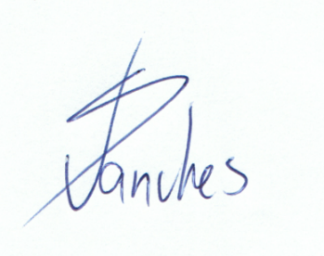 | 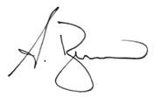 |  | 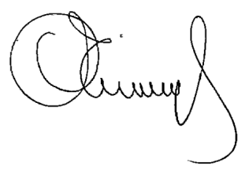
Valter Sanches  General Secretary  IndustriALL Global Union | Sharan Burrow  ITUC General Secretary | Luca Visentini  ETUC and PERC General Secretary | Luc Triangle  General Secretary  IndustriAll European Trade Union

